35kv no breakdown

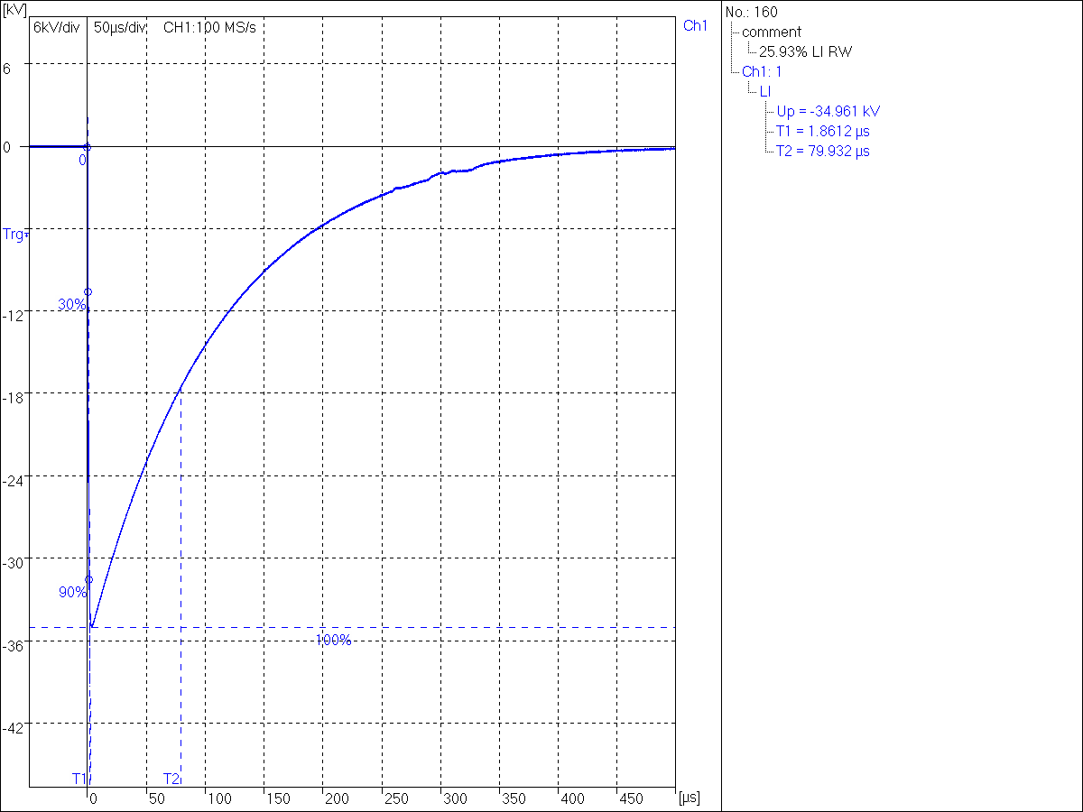

38kv breakdown

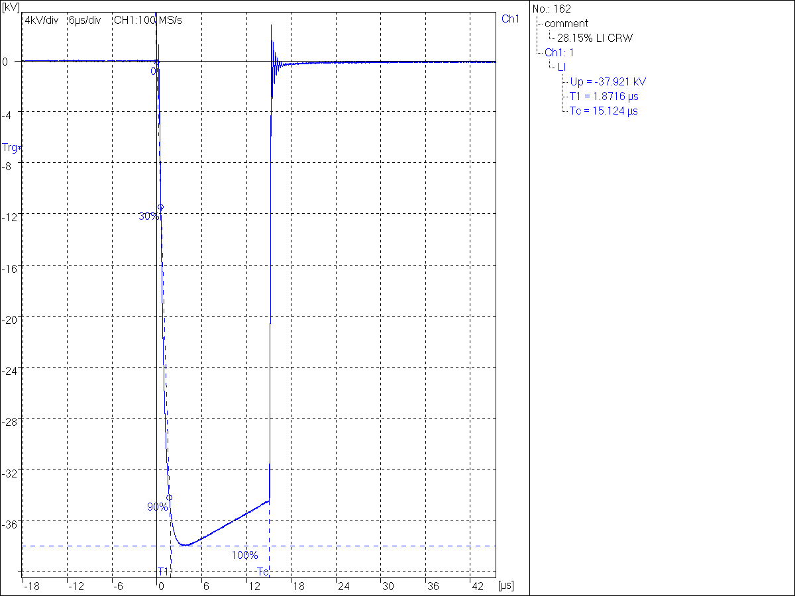

-45kv

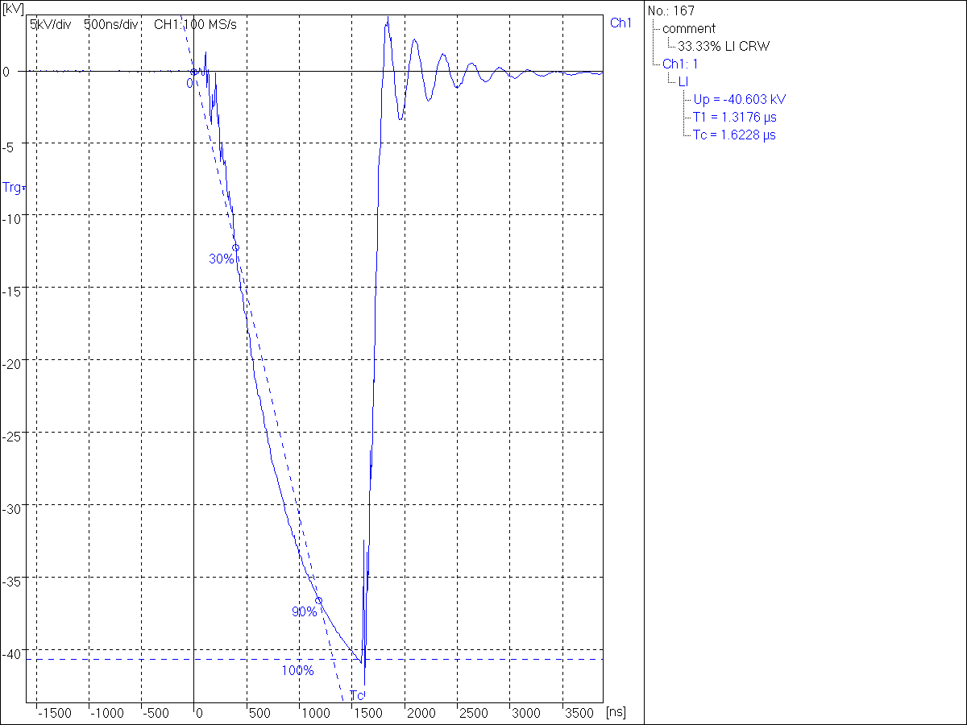

-55kv

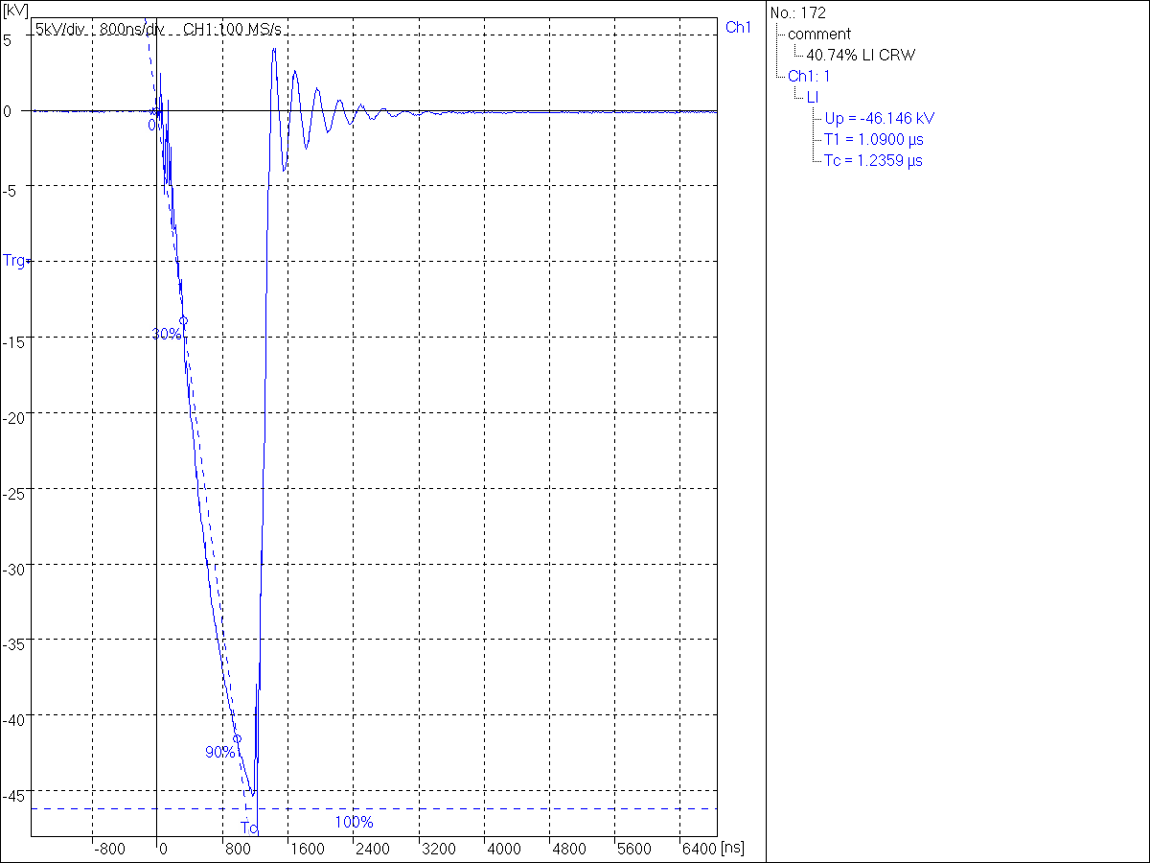

55 kv with surge arrestor

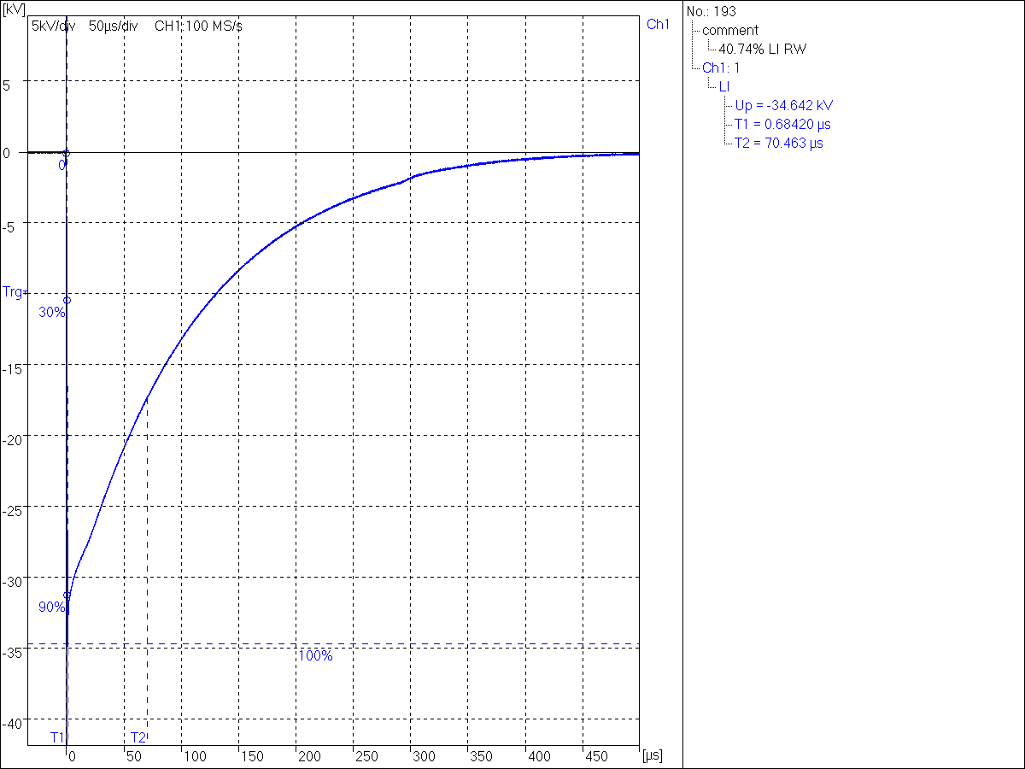

-45 kv with breakdown 10mm

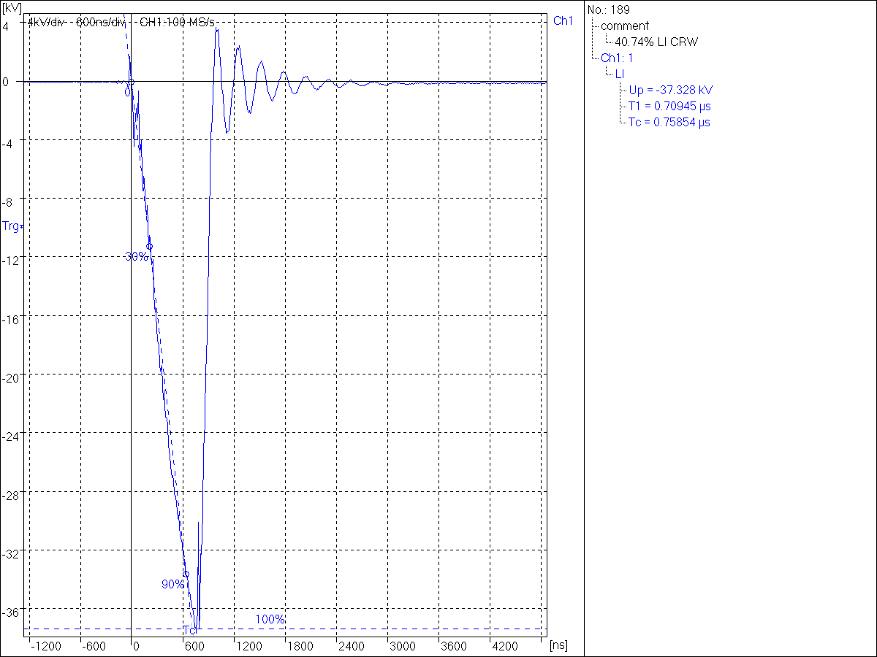

-55kv 10mm



AC voltage rectified by the two diodes to charge C1 with a DC voltage. The test is carried out first before without the test object to see the impulse voltage waveform that is generated in C2 and, therefore, efficiency of the system. The SW assumes the efficiency is 1 so the test need to be carried out without the test object to calculate the real efficiency. The test’s procedure consists in using a software to apply a peak DC impulse voltage to C1. The distance of the sphere gap is changed automatically based on the charging voltage of C1. A negative lightning impulse voltage is applied to C1 to see the breakdown voltage between the sphere’s gap. This value is noted down together with the time it takes to reach the breakdown point.